**DOCUMENTATION**

* Software Development Life Cycle (SDLC) is a framework that defines the steps involved in the development of software at each phase.
* SDLC documentation provides us a detailed insight about the flow of work that needs to be done before actually getting started with the real development of the project.
* SDLC is a process which defines the various stages involved in the development of software for delivering a high-quality product as per the customer’s requirement.

Phases of Software development Life Cycle are,

1. Planning
2. Requirements
3. Design and Prototyping
4. Software Development
5. Testing
6. Deployment
7. Operations and Maintenance

There are around six most commonly used SDLC Methodologies,

1. Waterfall Model
2. V-Shaped Model
3. Iterative Model
4. Spiral Model
5. Big Bang Model
6. Agile Model

The most effective method of these is Waterfall method, this method is been deployed in the creation of Website.

**WATERFALL Model**

It is also referred to as a linear-sequential life cycle model. The waterfall Model illustrates the software development process in a linear sequential flow. This means that any phase in the development process begins only if the previous phase is complete. In this waterfall model, the phases do not overlap.

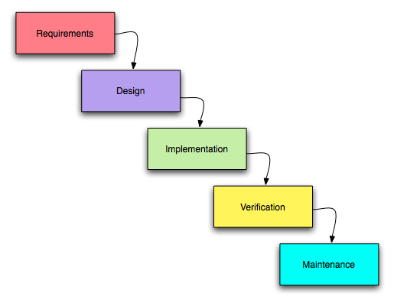

**Problem Statement**

To create a portfolio website which has a theme applied in common to all the web-pages it contains and should look aesthetically appealing and responsive. In addition to add two utilities in the web-page which is to be interlinked with each other.

**Approach to the Task:**

* **Requirements**

The first stage of the SDLC is the creating an overall outline of the website and the requirements needed for developing the website are gathered. The key requirements required are,

1. Theme
2. General layout of the website
3. Wireframe Designing (draw.io)
4. Unique webpage for the site containing contents such as Home, About, Academics, Achievements, Utilities & Contact details.
5. Text Editor to develop website. (Visual Studio)
6. Repository to access my work remotely when needed. (GitHub)
7. Platform to test the performance of the website. (lighthouse)
8. Display the image and content of the website.
9. Local Hosting (IIS)

* **Design and Prototype**

A wireframe is a visual representation of a user interface, stripped of any visual design or branding elements. It is used by UX Designers to define the hierarchy of items on a screen and communicate what the items on that page should be based on user needs.

It acts as blueprint design of the website and designed using draw.io and an example for it looks like,

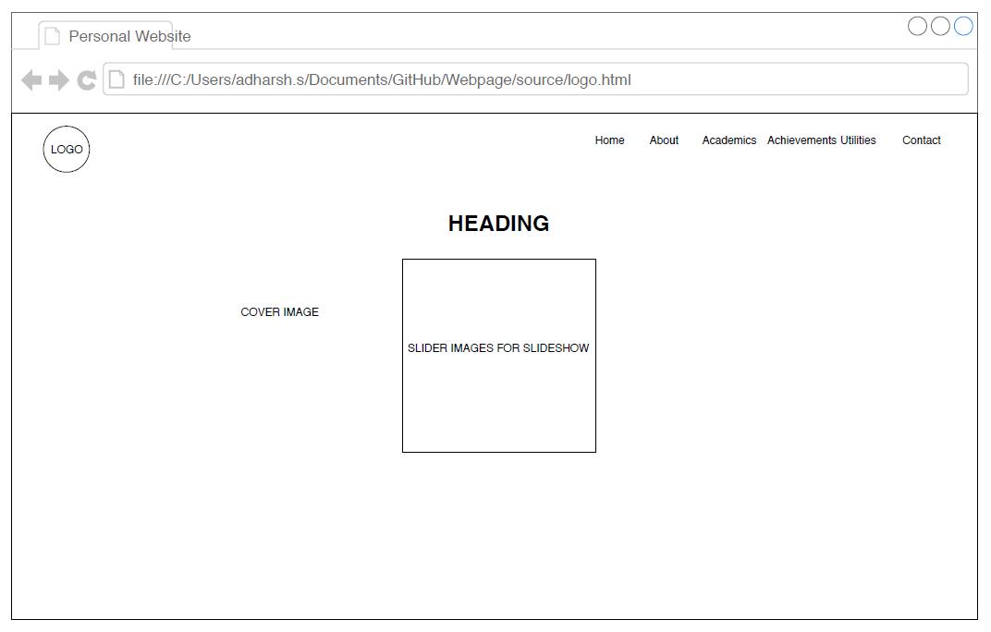

* **Software Development**

Based on the designed wireframe model and the requirement, the actual source code is being developed in this phase. This phase includes the complete development of code from the beginning to the end of the website development. While developing the code, best practices which suits the industrial standards should be followed,

* HTML5 is used for defining the contents that needs to be included in the web-pages.
* CSS is used to style the website contents into an attractive and appealing manner.
* JQuery plugins are used for image slideshow in the gallery and for the utilities development.
* **Testing**

In this phase the individual web-pages are integrated together with each other through means of links to form a meaningful website. The website once developed needs to be rigorously tested for errors and bugs and the feedback from these testing should be taken into account and should be rectified in the design/development process.

The testing methods includes,

1. Verifying that no dead pages or invalid redirects
2. Verifying the work flow of system.
3. Ease of Code.
4. Testing the functionality of links in all pages.
5. Testing the navigation and controls.
6. Checking the content in each webpage.
7. Checking the responsiveness of each page if they viewed in tablets and mobile phones.

Further the website is tested in google lighthouse which gives the following result as,

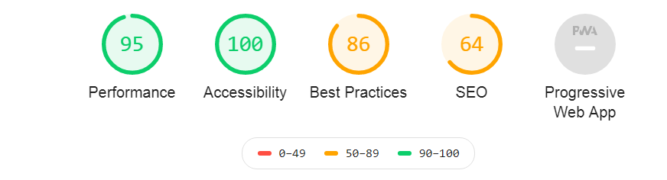

* **Operation and Maintenance**

1. Once the software testing phase gets over and no bugs or errors are reported then the implementation process starts.
2. The website was locally hosted by using IIS web-server.